Injection: Flawed handling of user input that allows attackers to execute malicious code, such as SQL injection or Cross-Site Scripting (XSS).
What is SQL injection and how to prevent it.
SQL injection is one of the oldest tricks in the hacker handbook, but it’s still incredibly dangerous. SQL injection is a type a attack that happens when someone finds a way to mess with the SQL queries your app sends to the database. Normally, those queries are supposed to do things like fetch a user’s profile or update a product listing.
Example of a typical query from a web form Suppose a login form collects a username and password:
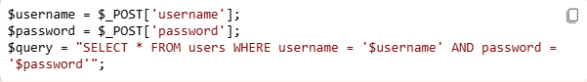
If the application directly inserts user input into query, an attacker can inject SQL code.
For example:
- Bypass authentication
- Access, modify, or delete data
- Dump entire databases
- In severe cases, gain administration access
There is different type of SQL Injection
- In-band SQLi = the attacker sends a malicious SQL query and gets the results right back through the application.
- Error-based SQLi= this technique relies on the database helpfully returning error messages. These error can reveal a ton of useful info, like table names or the structure of queries, which makes it easier for the attacker to plan their next move.
- Union- based SQLi= the attacker uses the UNION operator to combine their own query with the your app is running. It’s a clever way to pull extra data out of the database and sneak it into the response.
- Out-of-band SQLi= Data is exfiltrated using a different channel (e.g., DNS or HTTP requests)

Common SQL Injection Techniques

This one’s a classic. Imagine a login form where you’re supposed to enter your username and password. An attacker might enter something like this:
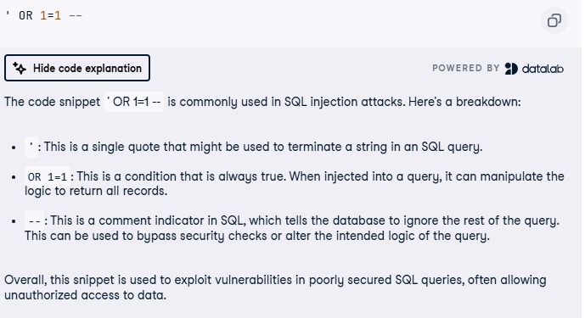

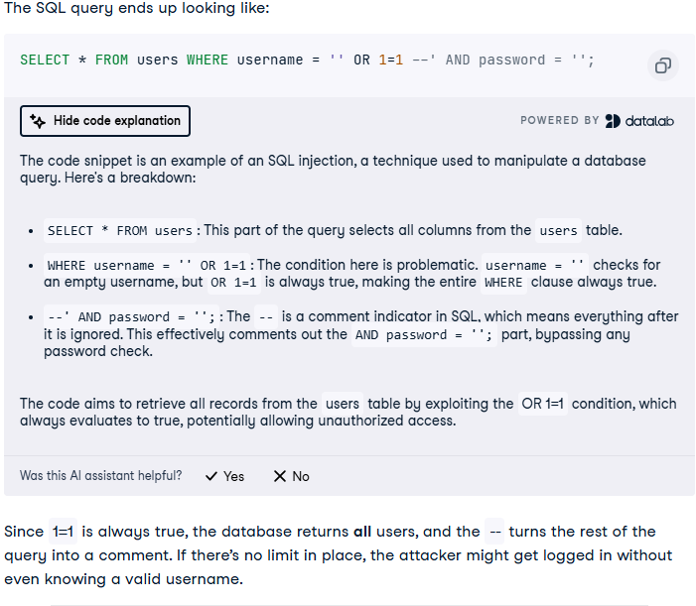
How to prevent SQL injection
Use parameterized queries
This is the number one rule. Never build SQL queries by gluing strings together. Instead, use placeholders and pass user inputs as parameters. Most frameworks and libraries make this super easy.
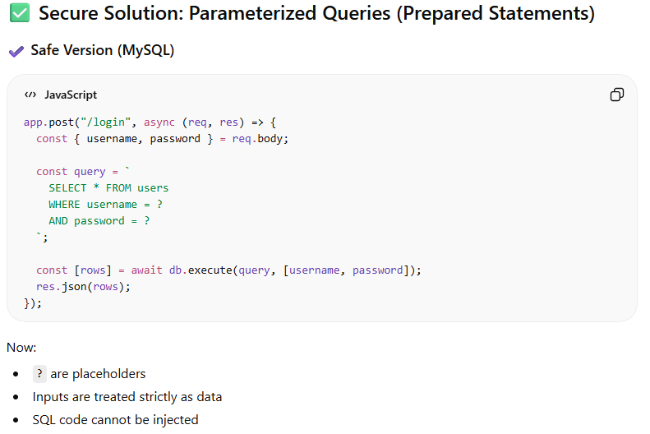

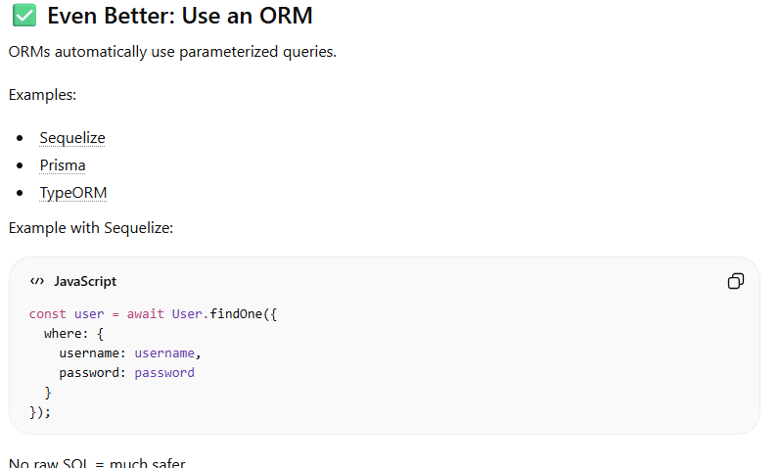
You can also add hashing within the database
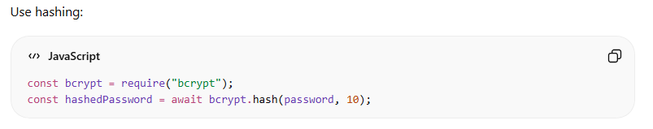
I hope this helps
I got this information from https://www.datacamp.com/tutorial/sql-injection
As for code you where it is, I don’t if it helps but it give an idea.

